**Hassan Ali - K201052 - BSE-7B**

**Lab 01: Build a web application on Azure platform as a service offering**

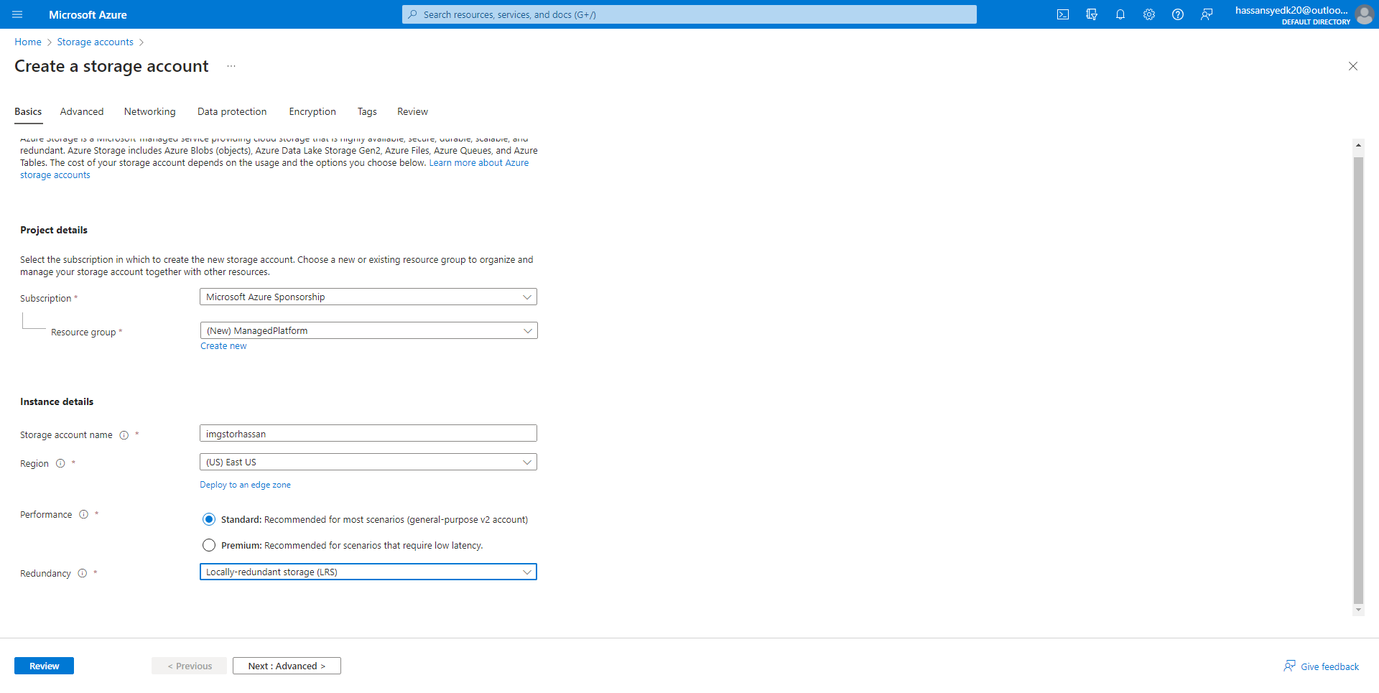

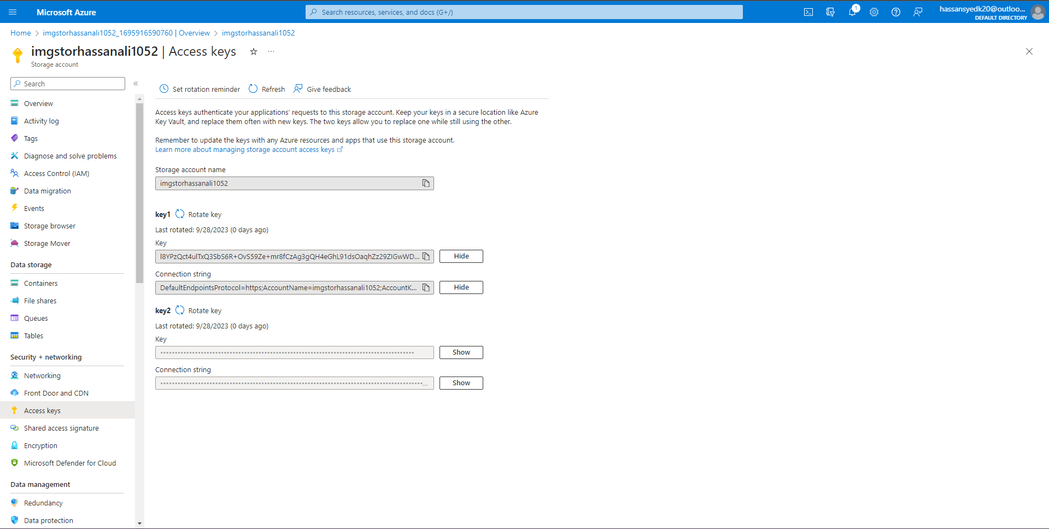

**Connection string:** DefaultEndpointsProtocol=https;AccountName=imgstorhassanali1052;AccountKey=l8YPzQct4ulTxQ3SbS6R+OvS59Ze+mr8fCzAg3gQH4eGhL91dsOaqhZz29ZIGwWDcJ/eZa/HlMIv+ASt88ntJg==;EndpointSuffix=core.windows.net

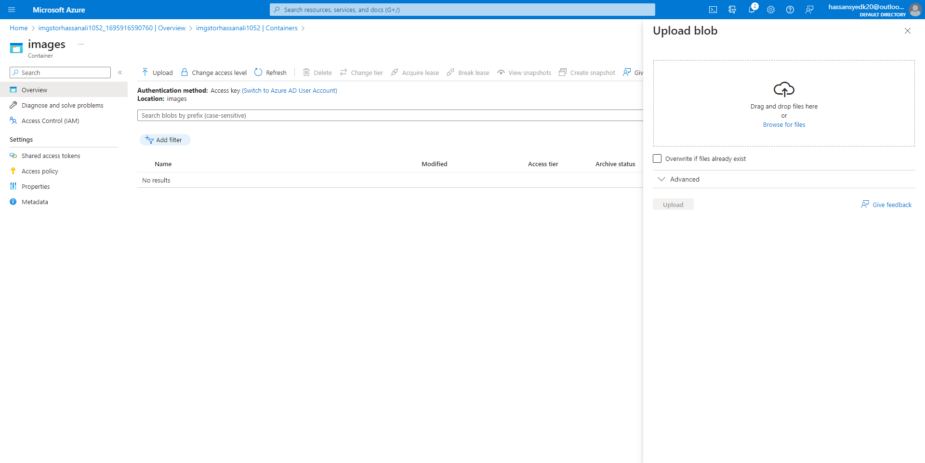

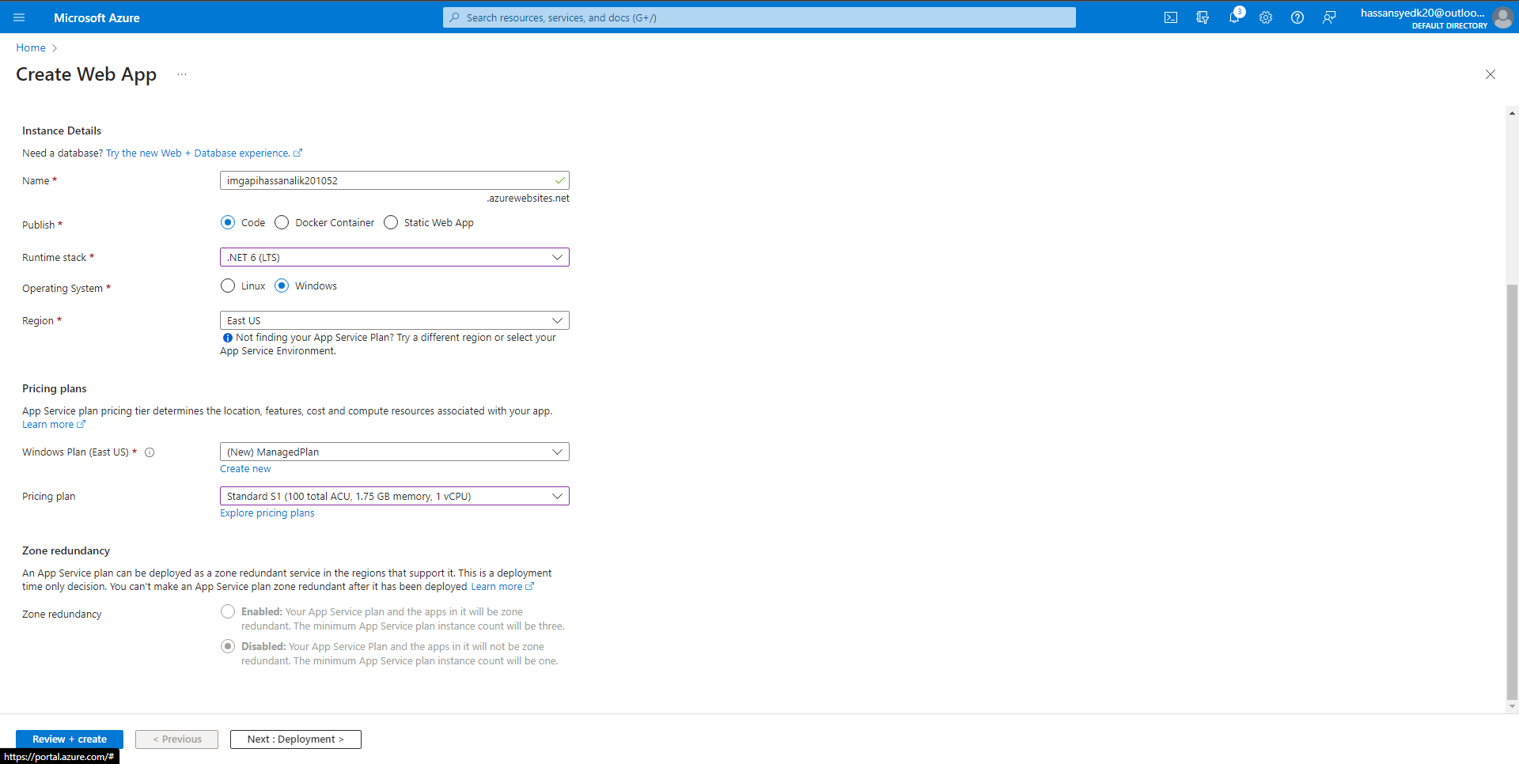

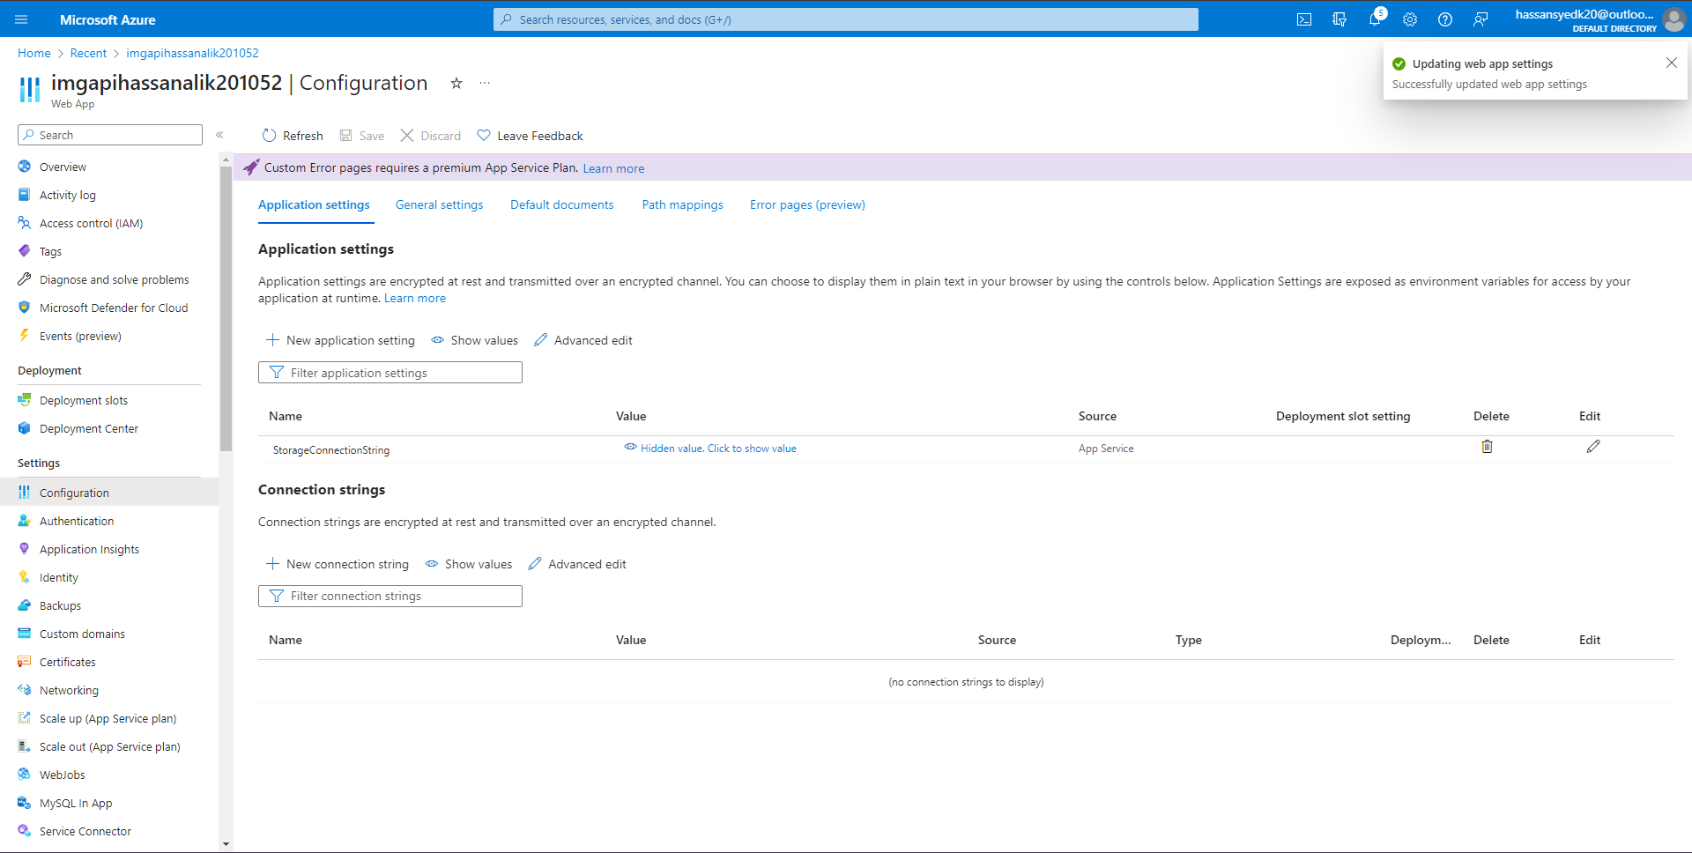

Default domain: <https://imgapihassanalik201052.azurewebsites.net>

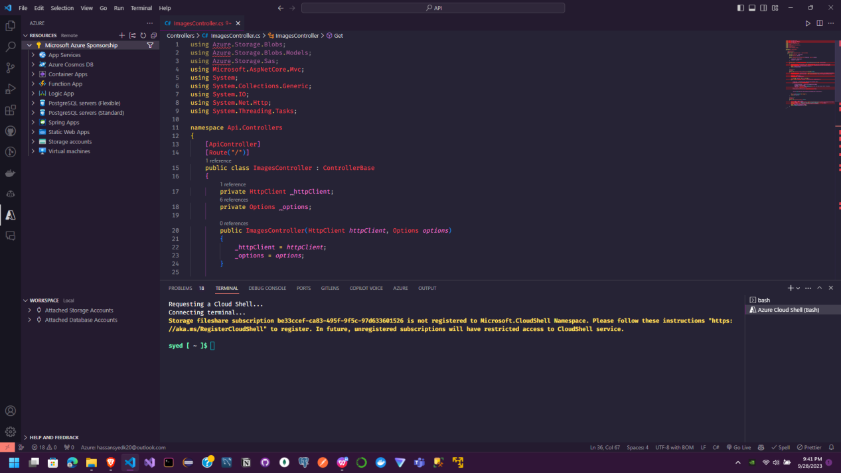

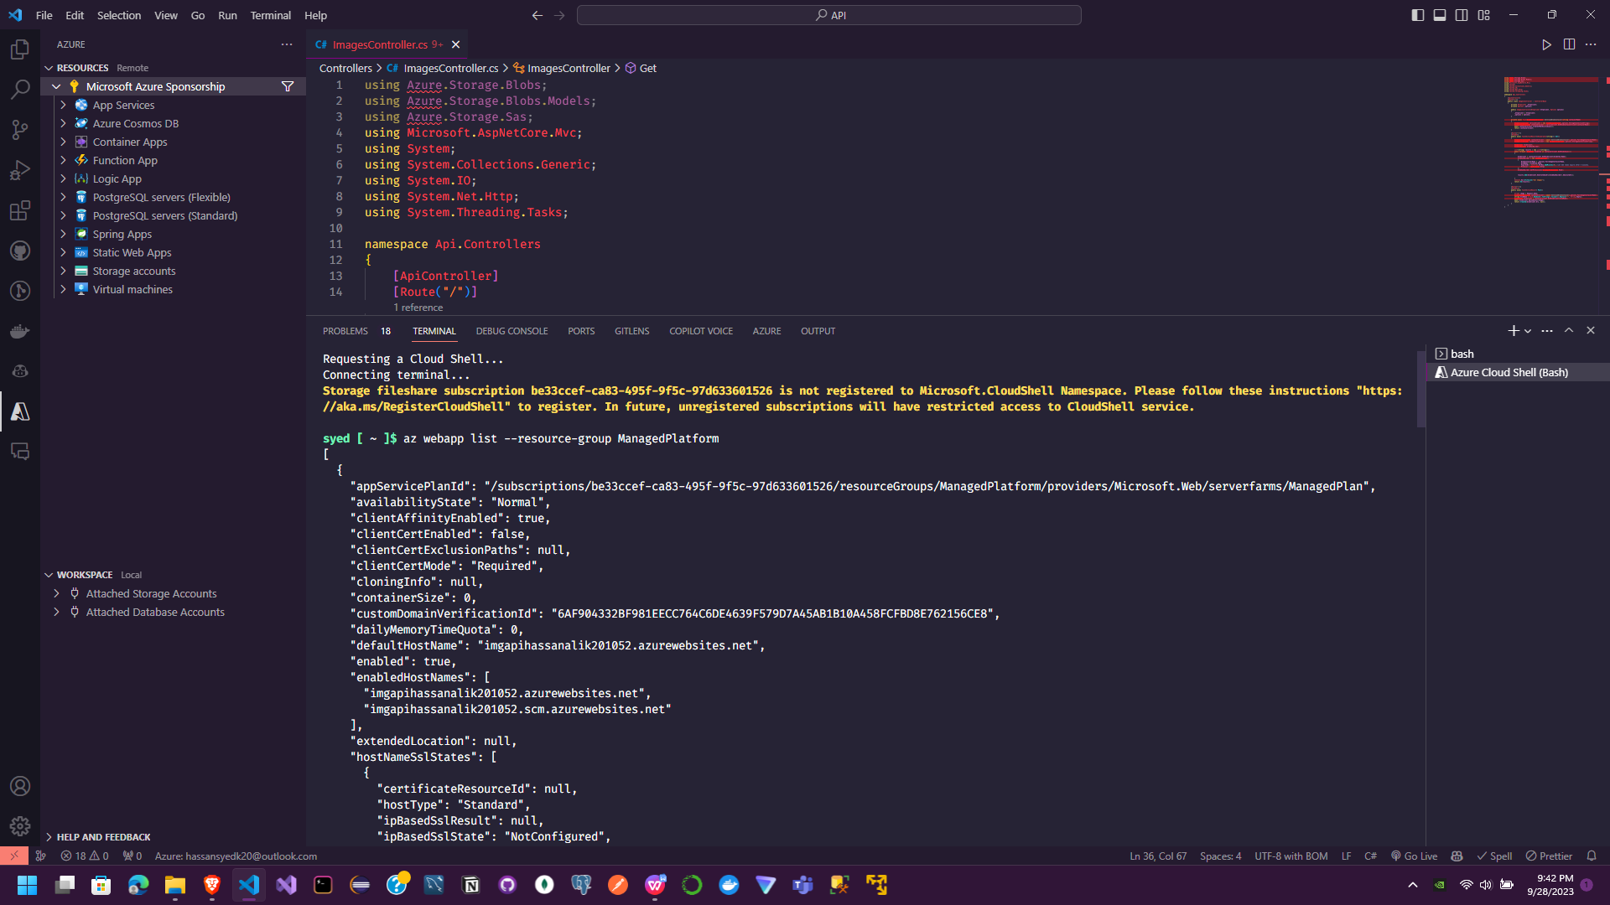



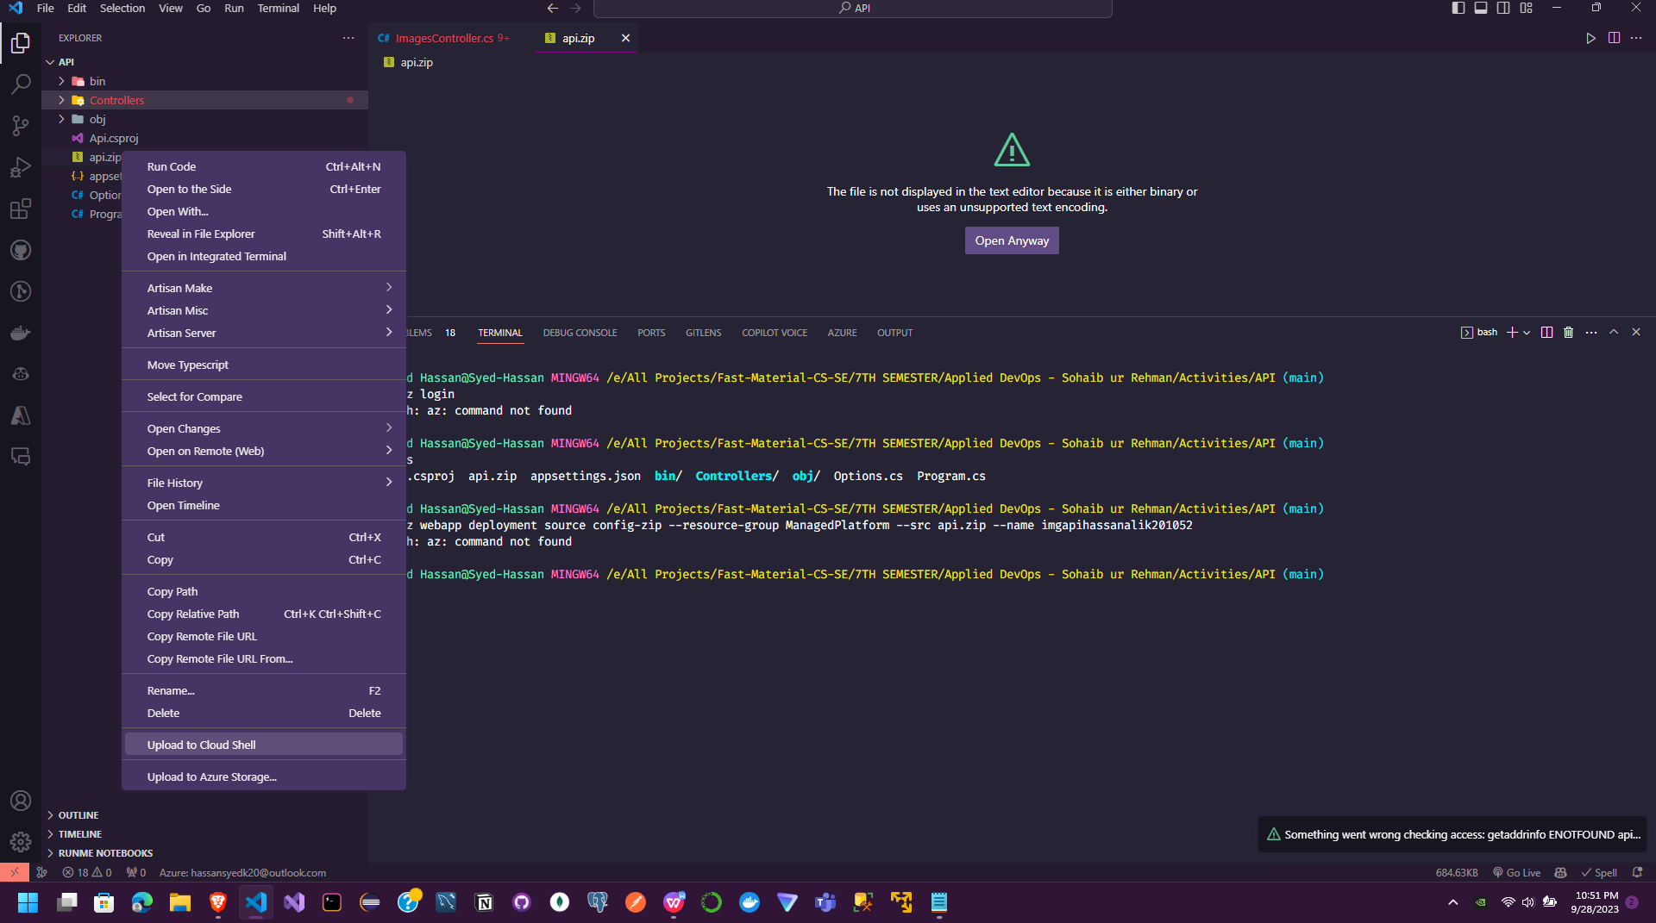

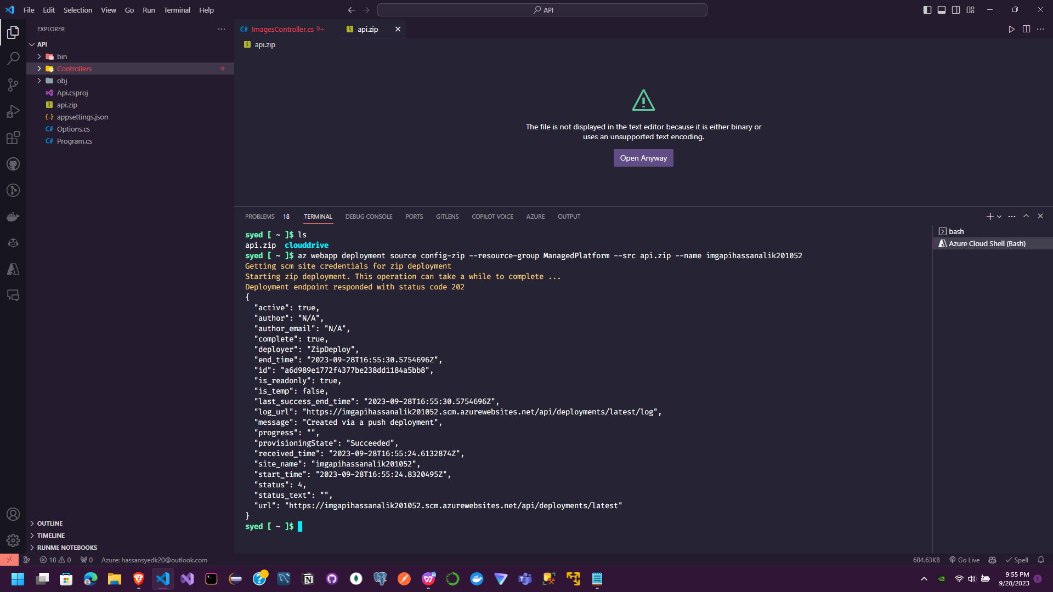

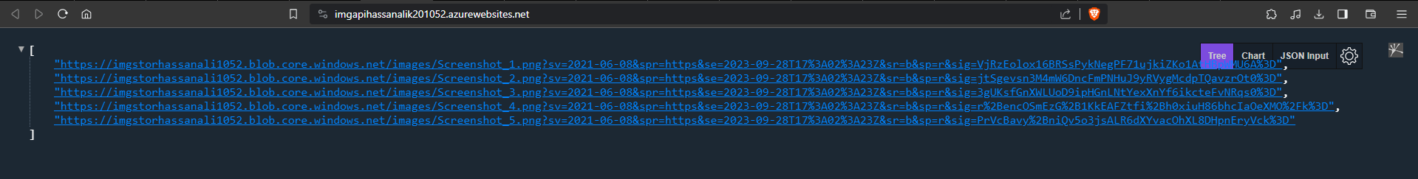

**Lab 01 Task 2: Build a front-end web application by using Azure Web Apps**

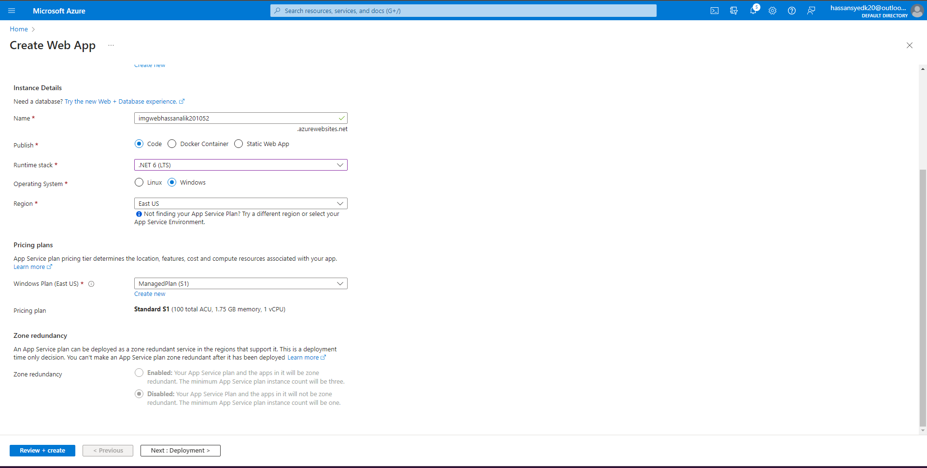

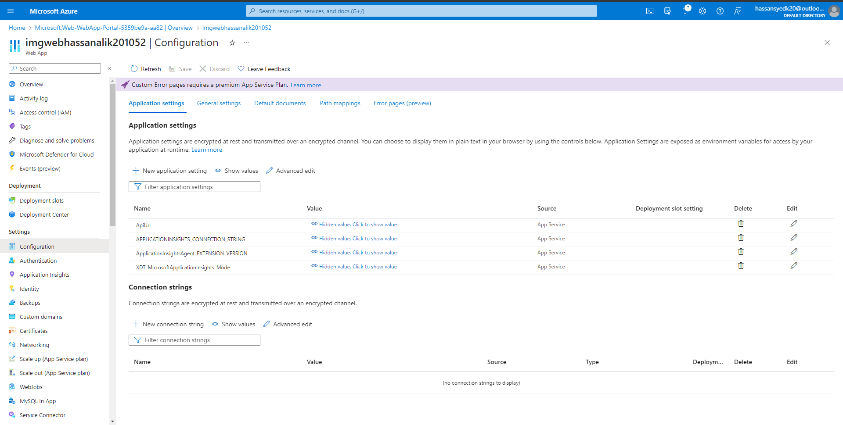



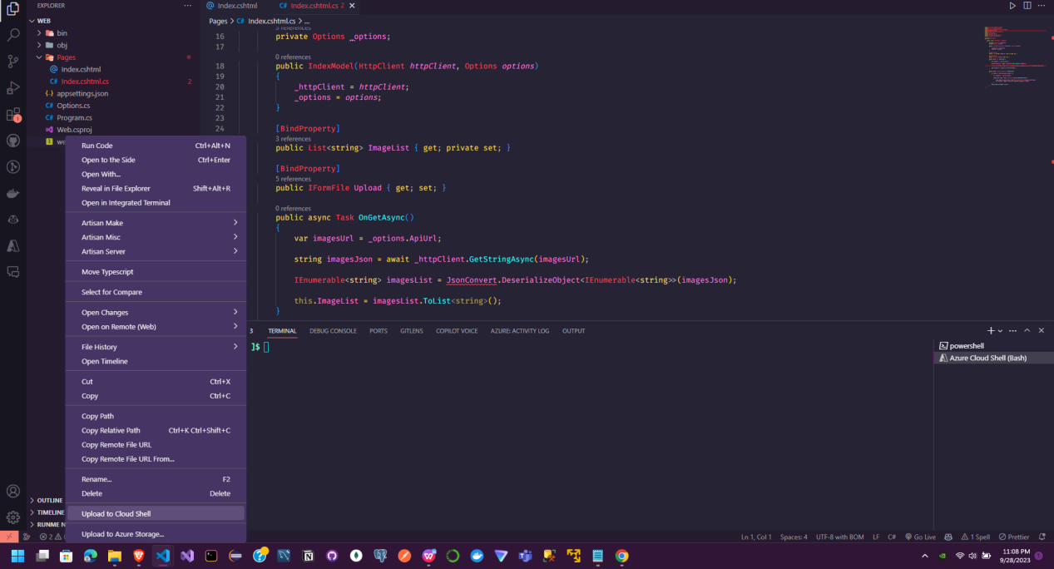

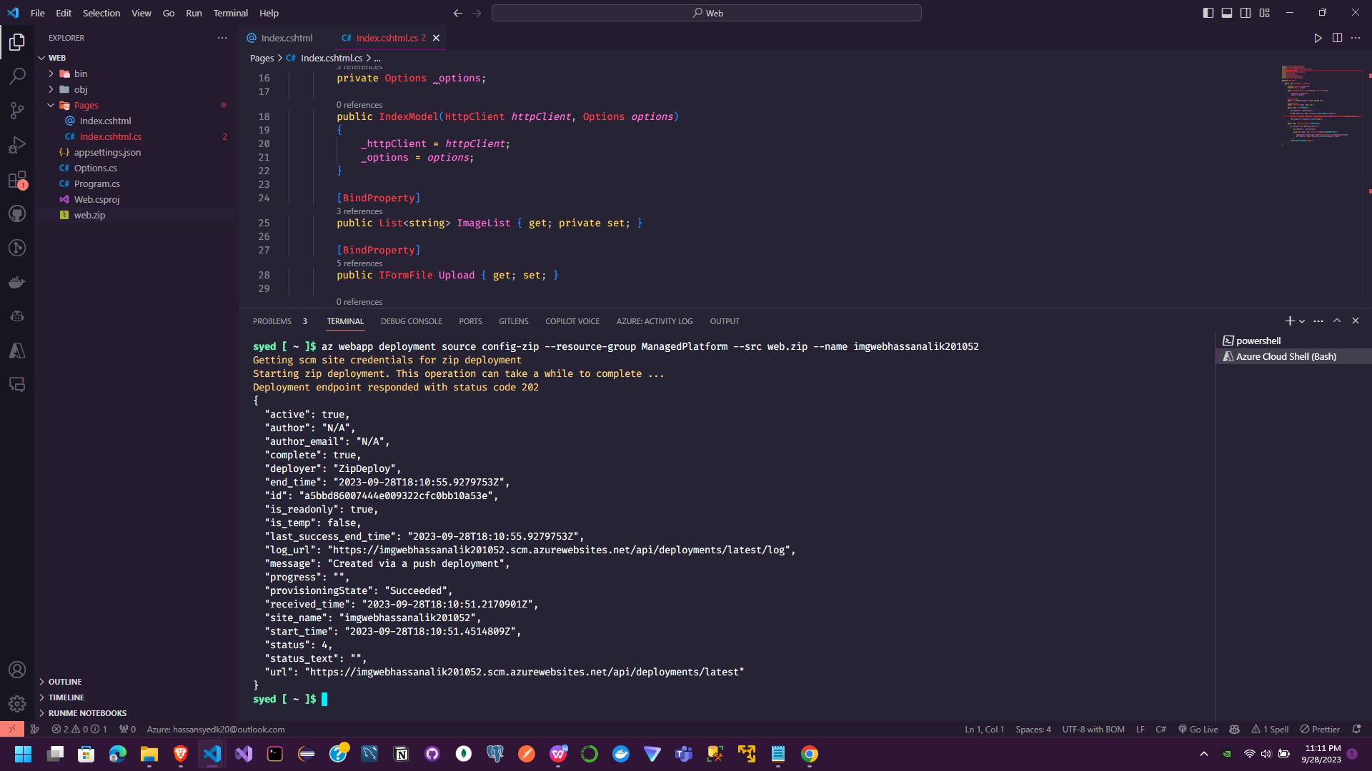

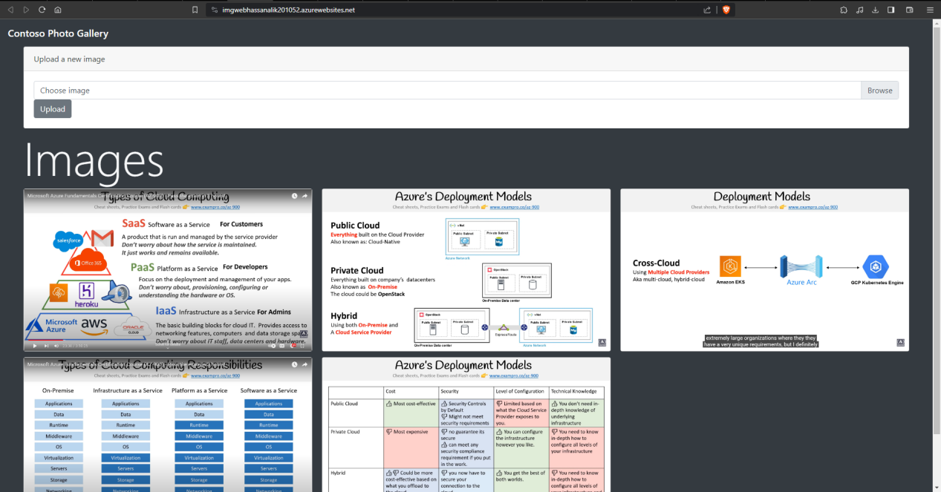

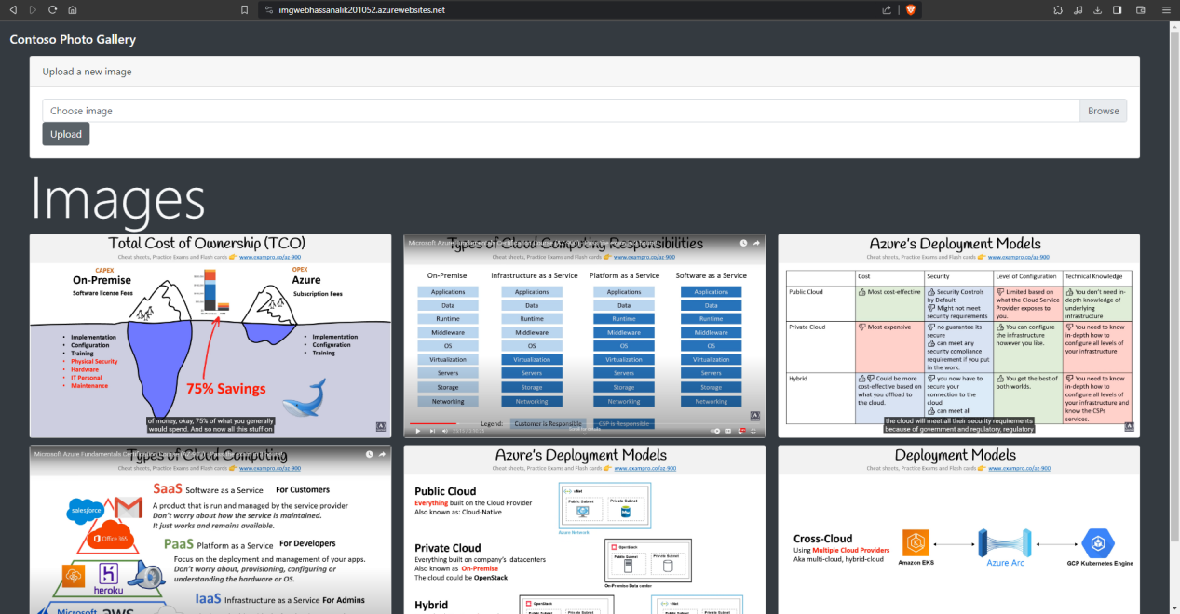

The main steps in the lab are:

1. Create an Azure Storage account and upload a sample image blob. This provides storage for images that will be used by the web app.

2. Create an Azure Web App for the backend API. This will host the ASP.NET code for the backend API that retrieves images from Azure Storage.

3. Configure the API web app with the Storage account connection string. This allows the API code to connect to the Storage account.

4. Deploy the API code to the API web app using ZIP deploy. This deploys the ASP.NET code that implements the backend API.

5. Test the API by browsing to it. This verifies it is returning the image URL from Storage.

6. Create another Azure Web App for the front-end. This will host the front-end ASP.NET code.

7. Configure the front-end web app with the API URL. This allows the front-end to call the backend API.

8. Deploy the front-end code to the front-end web app using ZIP deploy. This deploys the ASP.NET code for the front-end web app.

9. Browse the front-end web app. This tests it is displaying the image from the API and allows uploading a new image.

The overall goal is to use Azure App Service and Storage to build a functioning web application with a backend API and front-end UI using Platform as a Service. The steps deploy code to pre-configured web app resources rather than provisioning virtual machines.